Header

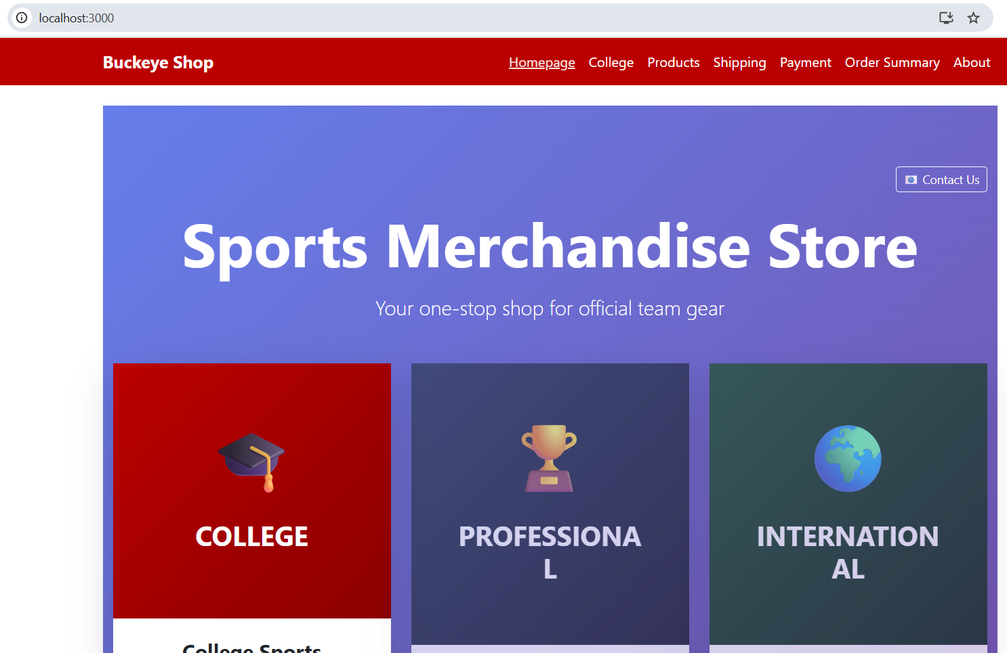

—----------------------------------------------------------------------------------------------------------------------------

Footer

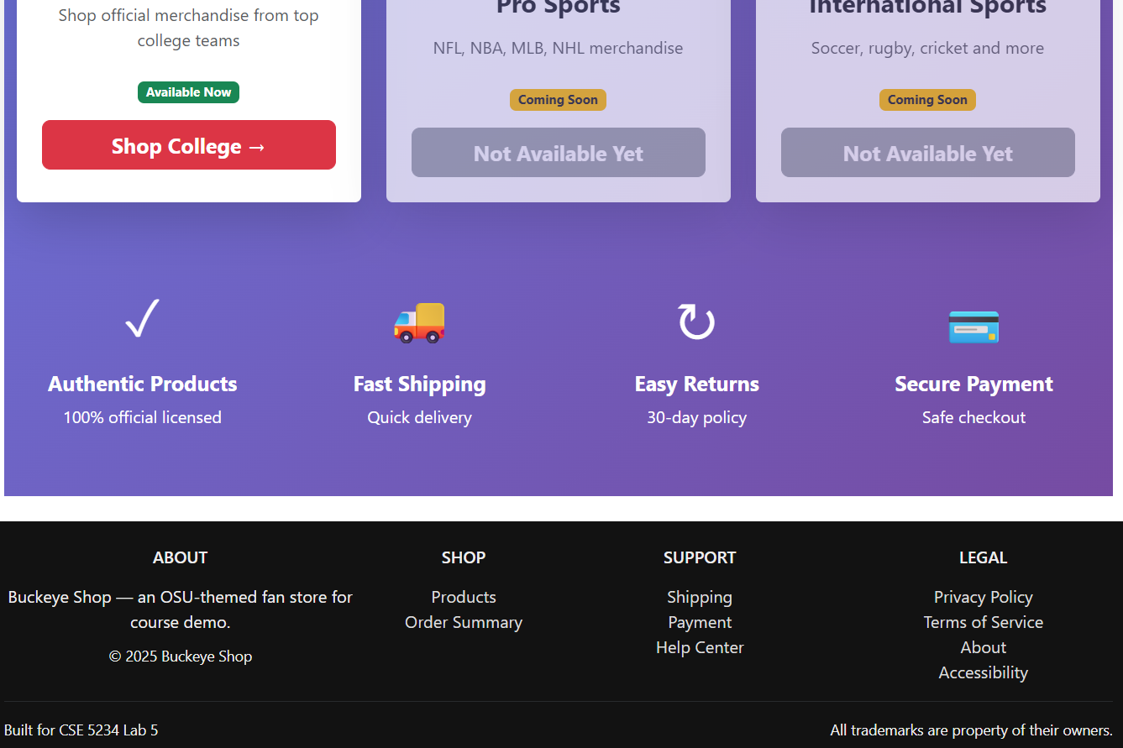

—----------------------------------------------------------------------------------------------------------------------------

Home page

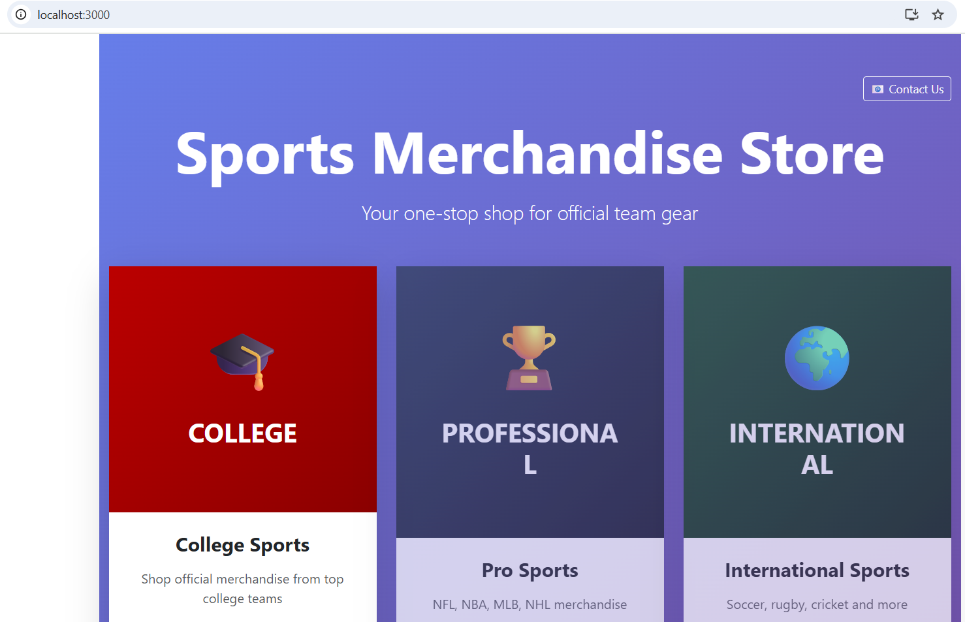

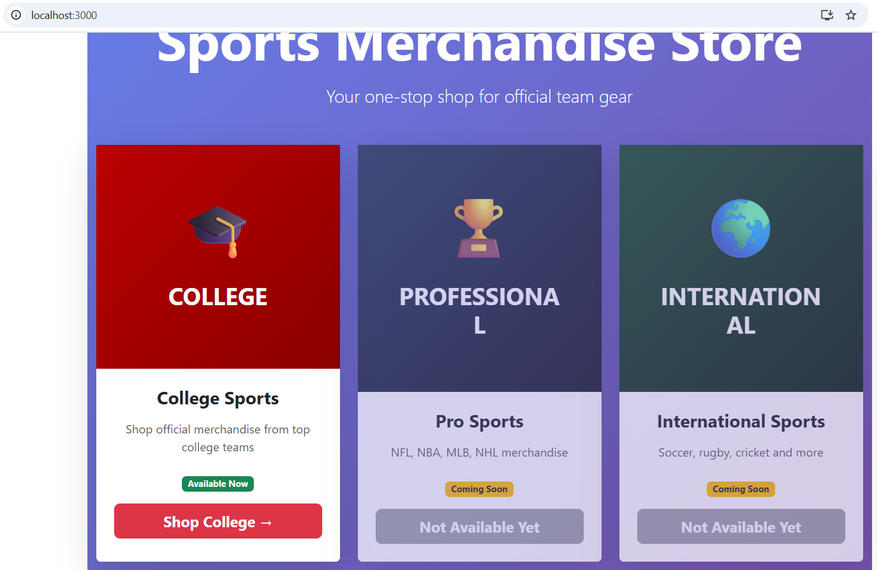

—----------------------------------------------------------------------------------------------------------------------------

Product page

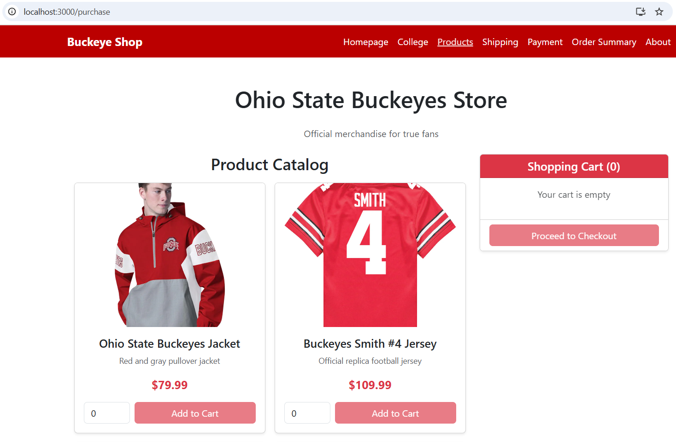

—----------------------------------------------------------------------------------------------------------------------------

Contact us

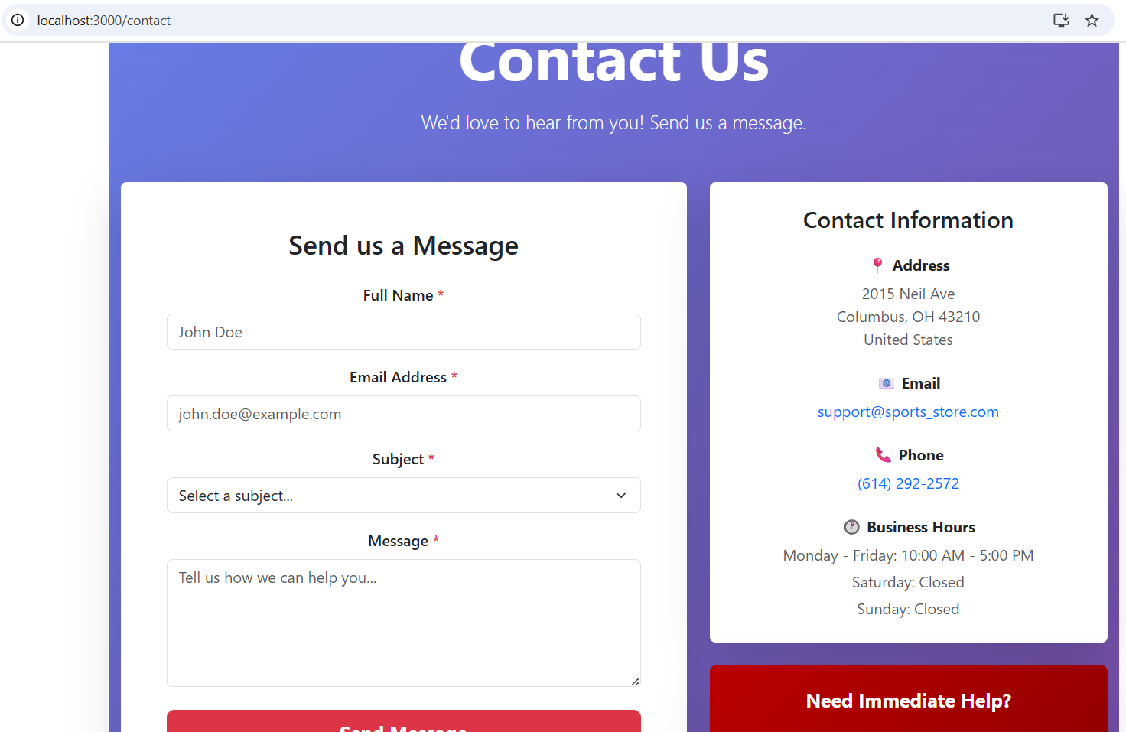

—----------------------------------------------------------------------------------------------------------------------------

About Us

